

**Modeling and Simulation**

**10204330**

**Section (2)**

**Application of Modeling and Simulation in Computational Neuroscience**

**Submitted to**

Dr. Murad Yaghi

**Submitted on**

June 22nd, 2024

**Submitted by**

Marwan Tarek Shafiq Al Farah

**Student ID**

21110011

**Spring Semester 2023 - 2024**

**Table of Content**

***Task I*** 3

***Describe and investigate the single-neuron modeling principles*** 3

***Investigate the benefits of applying modeling and simulation for simulating the neuronal dynamics*** 5

***Simulate each equation using Python and plot the results for each equation*** 7

***Explain the theoretical principles of each equation and the effect of varying the differential equation’s parameters*** 7

***Simulate the second-order system that consists of both equations together, where is the input, and is the output*** 9

***Explain the theoretical principles of the second-order system and the effect of varying the differential equation’s parameters*** 10

***Use empirical data to tune the parameters of a simulation model*** 12

***Apply different optimization techniques to tune simulation parameters*** 12

***Task II*** 13

***Design a detailed workflow for solving a specific problem using modeling and simulation*** 13

***Evaluate the performance of the second-order system in achieving desired behavior*** 14

***Analyze the effectiveness of each optimization technique for tuning the parameters of the simulation using empirical data*** 17

***Task III*** 21

***Investigate Previous Methods and Work done in the field of Neuronal Modeling*** 21

***Critically analyze and compare the performance of different models used for neuronal modeling and simulation*** 23

***References*** 27

# ***Task I***

***Describe and investigate the single-neuron modeling principles***

**(Lindsay *et al.*, 1999; Herz *et al.*, 2006; D’Angelo *et al.*, 2013; Brunel, Hakim and Richardson, 2014)**

Single neuron modeling can still be described as an essential branch of computational neuroscience that primarily focuses on analyzing the functional properties of neurons based on the use of mathematical and computational techniques to simulate neuronal activities and behaviors. There are several goals of using these models; the most fundamental of which is being able to mimic the electrical and biochemical properties of neurons as well as the generation of action potentials and the transmission of synapses. These models are thus valuable as tools for understanding the functional logic of neurons and how the nervous system can be explored at its most fundamental level.

**Historical Context and Previous Work**

The study of single neuron modeling has a long history and a lot of researchers’ efforts are devoted to its development. The most often cited and recognised one of the first and the simplest models is the Hodgkin-Huxley model from the early 1950’s. This model explained how action potentials in neurons were triggered and how they travel through the use of mathematical calculations that describe ionic currents. Other developments that have occurred are the FitzHugh-Nagumo model that simplified the Hodgkin-Huxley equations; and the Leaky Integrate-and-Fire model, that gave a more computationally efficient means of simulating neuron’s activity in large network.

**Basic Principles of Neuronal Modeling**

Neuronal models are mathematical frameworks that represent the properties and behaviors of neurons. All these models are essential for the computational modeling and prediction of the neuronal activity and for the understanding of the experimental results. At the core, these models endeavor to reflect the electrical behavior of neurons with a cornerstone of their aptitude for generating or propagating electrical impulses referred to as action potentials.

**Types of Neuronal Models**

* **Biophysical Models:** These models, such as the Hodgkin-Huxley model, contain in their description ionic currents and the biophysics of these processes in term of differential equations. They provide accurate results in reproducing electrical activity of neurons depending on certain conditions despite the fact they need large amount of computational power because of their complexity.
* **Integrate-and-Fire Models:** Derived from biophysical models, integrate-fire models provide a simplified representation of neuron’s response by reducing the process to a threshold-based signal generation. Once the membrane potential reaches a certain threshold, a spike is released and the membrane potential is reset. These models are generally less computationally demanding and are thereby applied to large networks of neurons.
* **Compartmental Models:** These models simulate different parts of a neuron (e. g. , somas, axons, dendrites) as connected but separate entities that all contribute to the neuron’s functionality; as it allows for different parameters such as voltage or concentration of ions over the neuron’s structure. Compartmental models can be adjusted in complexity and are particularly useful in studying dendritic function and its effects on neuronal output.
* **Reduced Models:** For example, FitzHugh-Nagumo and Morris-Lecar models, which reduce the complexity of biophysical models and capture the critical features of neuronal dynamics without stress on the ionic current.

**Purpose and Application of Modeling a Neuron in Computational Neuroscience**

The modeling of neurons serves several critical purposes:

* **Understanding Neural Mechanisms:** Models are useful in analysing detailed comprehensions of the neurons, such as the mechanisms through which neurons convey information through electrical signals.
* **Drug Development:** Through modelling the reactions that neurons give when exposed to different chemicals and molecules, scientists can estimate whether a medicinal product will be effective or toxic, and how fast a new treatment can be discovered and brought to market.
* **Neural Prosthetics and Brain-Machine Interfaces:** They play a crucial role of aiding in the development of neural prosthetics through indications on how neuronal information is processed. Neuron models therefore play a part in designing devices that can function directly on the nerves which can be used in cases of neurological diseases and accidents.
* **Advancements in AI and Machine Learning:** Neuronal dynamics lead and is leading to much of the progress in such areas like Machine Learning as well as Artificial Intelligence, especially in the creation of structures of neural networks that are similar to the operating structure in the human brain.

**Additional Considerations**

Single-neuron modeling also takes into account the neuron’s environment, including interactions with other neurons as well as the interactions of neurotransmitters and neuromodulators. Moreover, the advancements in computational tools and algorithms, for instance, machine learning and deep learning methodologies in particular, are constantly enhancing the accuracy and reliability of these models as well.

**Challenges and Future Directions**

Even though single-neuron models have considerably enhanced our comprehension of the neuronal dynamic properties, there are restrictions for example in the conflict between is bio-realism and computational feasibility. Several studies are prospective, addressing the issues of multiscale modeling, which associates the internal mechanisms of an individual neuron with overall activity of a great number of connected neurons.

***Investigate the benefits of applying modeling and simulation for simulating the neuronal dynamics*** (Hines and Carnevale, 1997; Carnevale, 2007; Brunel, Hakim and Richardson, 2014; Markram *et al.*, 2015; Einevoll *et al.*, 2019; Awile *et al.*, 2022)

In neuroscience, prescriptive and descriptive modeling and simulation have gained crucial importance mainly to explore and predict neuronal dynamics, although mainly used for analyzing and predict neuronal and neural networks actions. This section looks at enhancement in the application of these techniques stressing on the impact in research and in practice in the area.

**Benefits of Neuronal Simulation**

The simulation of neuronal dynamics offers several advantages

* **Reducing Experimental Costs:** Simulation serves as an efficient tool for minimizing expensive and lengthy biological tests since it offers an initial outlook of what results could be anticipated when particular tests are conducted.
* **Enhanced Understanding of Neuronal Mechanisms:** Neuronal models enhance comprehension of complex dynamics of neurons as a result of their sophisticated structure and functional processes. As the electrical and chemical properties of neurons are modeled, researchers can explore the generation of action potentials, synaptic communication and integration occurring within a set of neurons can experiment on these models. A detailed look into the human brain clears such misunderstandings by offering concrete explanations on even the most intricate brain activities including learning, memory, and decision making.
* **Acceleration of Neuroscience Research:** Several simulation tools can be used to test hypotheses on the functionality of neurons and the corresponding behaviors under different scenarios, which is not easily accomplished through in vivo experiments due to time constraints or ethical considerations. Many big practical questions may be answered to as many adjustments of the parameters of models can be made by researchers which help to understand new things faster in the sphere of neuroscientific study.
* **Tool for Drug Development and Testing:** For instance in the pharmaceutical industry, neuronal models are quite useful in directing drug discovery as well as description. When used in scientific experimental models, neuronal activities can be precisely interacted with the pharmacological agents to estimate and predict the impact of drugs and side effects without necessarily having to conduct clinical investigations. This not only speeds up the development process but also enhances the safety and specificity of therapeutic interventions.
* **Advancements in Neural Prosthetics:** Modeling and simulation is very important applications in the design and optimization of neural prosthetics and brain-machine interfaces. These technologies need exact knowledge of how neurons perceive and transmit information to be able to integrate artificial devices with biological systems. Electrophysiological models of neurons may help researchers create machines that mimic or enhance neural mechanisms, providing new therapeutic approaches for individuals with neurologic disability.
* **Contribution to Artificial Intelligence:** The principles which are learnt from neuronal dynamics have been proved helpful in the enhancement of artificial intelligence. This way, AI researchers can design quite satisfactory and realistic neural network algorithms since the latter emulates neural processing. These models offer perspectives on learning and decision-making, the two core features that are fundamental to AI.
* **Facilitating Educational and Training Opportunities:** Neuronal modeling acts as a educational tool that enables students and researchers to gain basic knowledge about neurons without utilizing a laboratory apparatus at their disposal. Simulations provide a hands-on approach to studying neuronal behavior, enhancing learning and innovation in neuroscience education.

**Why We Use Simulation in Neuroscience**

One of the benefits of simulation is that it can be used as a versatile and effective means for analyzing the intricate nature of neuronal dynamics, which, in contrast, is hardly possible to study directly from living tissues because of the fragility of neurons and neural networks. Through simulation, researchers can:

* **Test Hypotheses:** In this simulation we see that it allows theoretical models to be tested under ideal conditions, thus giving them a reversible environment in which they can experiment with parameters which influence the neurons behavior.
* **Visualize Processes:** They allow visualizing neuronal processes at several magnifications and scales that are sometimes impossible with experimental approaches.
* **Conduct Infeasible Experiments:** It allows for scenarios that are hard to stage in a lab, costly, or even untenable from an ethical standpoint, like biological stages, or lengthy durations.

**Simulating Real Neurons, Parallels with AI, and Impact of Neuronal Simulation on AI Development**

While AI wants to mimic the inner functions of human cognition with help of algorithms and structures, neuronal simulations also are designed to mimic the real neurons and their functions. This involves creating action potentials, processing synaptic inputs and and integrating signals within neural circuits.

These insights from utilizing neuronal modeling are rewriting the blueprint of AI advancements. Understanding how neurons integrate and fire, and how networks of neurons process complex input patterns in an optimal way can enhance and be incorporated in advanced AI techniques, thus appearing to be rational want and need. Deep learning networks which are based on neuronal dynamics are advantageous in terms of learning capacity and plasticity that reflects functionality and optimization with regard to the new input data.

***Simulate each equation using Python and plot the results for each equation***

It can be found in the “Marwan AlFarah MS part 1 notebook Spring 23-24.ipynb” file attached.

***Explain the theoretical principles of each equation and the effect of varying the differential equation’s parameters***

The FitzHugh-Nagumo model is a ‘reduced’ version of the Hodgkin-Huxley model, that was initially conceived to model the neuronal electrical activity. One of the strengths of the model developed by FitzHugh-Nagumo is that it reconstructed the Hodgkin and Huxley’s complex biophysical model into just two differential equations explaining the neuronal excitability and action potentials. This model is especially helpful when it comes to understanding how the neurons utilize the stimuli and when it comes to how action potentials occur and happen. The first order system performed very poorly in comparison to the empirical data due to the fact that the membrane potential equation considers w as a constant and the recovery variable equation considers v as a constant, therefore, they do not capture the temporal dependencies of each other and they do not vary based on the other one’s value.

**Model Equations and Their Theoretical Principles**

The FitzHugh-Nagumo model consists of two primary differential equations:

1. **Membrane Potential Equation:**

This equation sets the basic conditions of the membrane potential () of a neuron. It refers to the nonlinear ionic currents through the neuron membrane labeled by the term and are necessary for action potentials. The term () adds nonlinearity to the model that resembles the initial rapid activation and then the inactivation of ion channels in the course of an action potential. represents a recovery variable, which abstractly models the slow recovery processes associated with the inactivation of ion channels. is a constant external current that represents an input stimulus for the neuron.

**Effects of Parameter Variations: External Current ():** This is the external current this means when changing the amount of the external current, one can mimic different amount of external stimulus on neuron. Based on this argument, an increase in encourages movement from quiescence to repetitive firing as observed in neurons in response to stronger synaptic inputs. It helps to examine how neurons process inputs under various input conditions, however this cannot be observed in our model as we are working with a first order system that is ignoring the second order system entirely and treating w as a constant thus unable to capture the actual changes that happen in real life neurons.

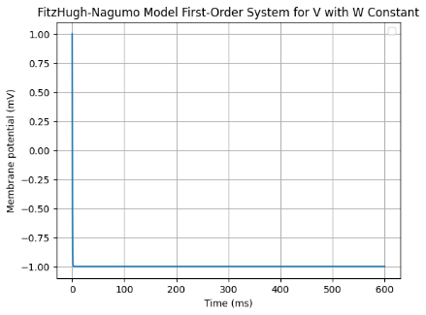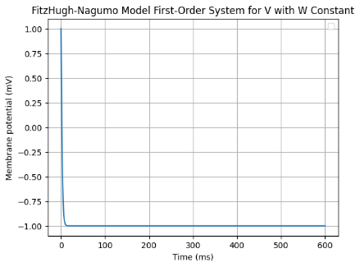

1. **Recovery Variable Equation:**

The variable serves as a recovery or adaptation variable, determining when the membrane potential returns to its usual level following an action potential. The parameters and govern the stationary behavior and stability of the recovery process, respectively. ε is a tiny parameter that changes the timescale of ’s evolution relative to , making ’s dynamics slower than ’s.

**Effects of Parameter Variations**

1. **Parameter :** This parameter determines the time response of the recovery variable , affecting the inter-spike interval, and modifying neuron shooting pattern. Lower is longer recovery time, less firing rate and these parameters allow model varieties of neuronal activity, which is based on slower recovery.

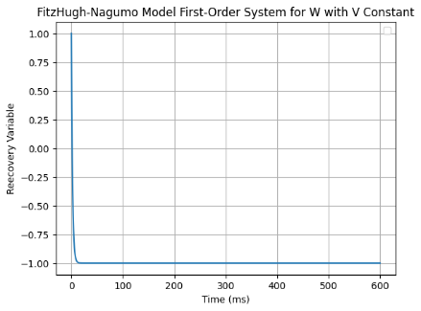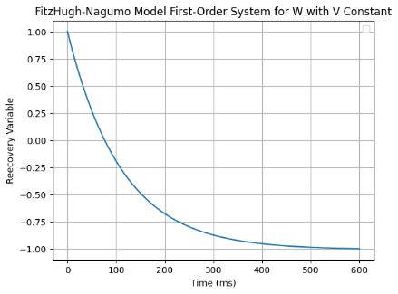

1. **Parameters and :**

* **Parameter** **:** alters the value of that marks the recovery period in the cycle It means that changing shifts the baseline level of the recovery variable and determines the action potential. For a higher value of is associated with lowering of the threshold such that enhance the ability to activate the neuron; while a smaller value increases the threshold such that deteriorates the ability of a neuron to be activated.

* **Parameter :** Affects the strength of the feedback loop between and . Changing the value of shifts the nature and stability of the neuronal oscillations observed. The effect of increasing is that the feedback is reinforced so oscillatory behavior is more pronounced whilst, if is decreased the feedback is dampened leading to stable but less dynamic behavior.

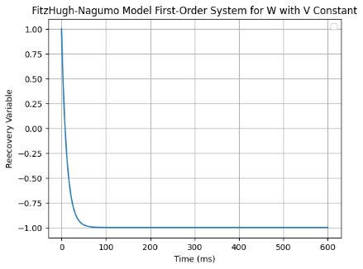

In computational neuroscience, the FitzHugh-Nagumo model is a significant model that decomposes the Hodgkin-Huxley model into faster and slower processes that interact to produce the dynamics of a neuron under different physiological conditions. By tweaking these parameters, researchers can study a wide array of neuronal behaviors, helping them understand the framework of the electrical properties of neurons and process by which action potentials are generated. This model not only facilitates the educational use but also allows a variety of studies regarding the neural computation and disorders interfering with the regularization of neural activity.

***Simulate the second-order system that consists of both equations together, where is the input, and is the output:***

It can be found in the “Marwan AlFarah MS part 1 notebook Spring 23-24.ipynb” file attached.

***Explain the theoretical principles of the second-order system and the effect of varying the differential equation’s parameters:***

The second-order system in the setting of neuronal modeling often involves two combined differential equations, representing the dynamics of the membrane potential and a recovery variable. In the FitzHugh-Nagumo model, these equations are drawn from the simplification of the Hodgkin-Huxley model, which explains the electrophysiological activity of neurons. The FitzHugh-Nagumo model simplifies the complexity of the biophysical model into two main equations, which provide an understandable framework for understanding neuronal excitability and action potentials. The second-order system is able to capture much of the empiracle data’s properties much more than the first-order system as it doesn’t consider w and v as constants in membrane potential and the recovery variable equations respectively, therefore, they depend on the previous iteration’s values, thus, are able to capture the temporal dependencies.

The FitzHugh-Nagumo model’s second-order system can be expressed as:

1. **Membrane Potential Equation:**

This equation controls the behavior of the membrane potential () of a neuron. The term ​ reflects the nonlinear ionic currents through the neuron’s membrane, which are important for generating action potentials. The cubic function adds a nonlinearity that mimics the rapid activation and subsequent deactivation of ion channels during an action potential. The variable w is a recovery variable that models the slow healing processes involved with the inactivation of ion channels. is an external input current that is a function of time, modeling the events affecting the neuron.

1. **Recovery Variable Equation:**

The recovery variable () describes how quickly the membrane potential comes back to its resting condition following an action potential. controls the stationary effects, while controls the stability of the recovery process. is a positive small parameter which control the rate of time variation with respect to time variation and we can observe that the rate of time variation will be generally less than the rate of time variation.

The above two coupled first order differential equations complete a second order differential equation system which qualitatively reproduce the neuronal traits especially regarding the action potential generation and propagation.

**Effects of Parameter Variations**

1. **External Current ():** The external current can be considered as the input stimulus of the neuron positioned externally to the neuron. can simulate different external stimuli, in this instance it remains fixed at 110 pA. Increasing the amplitude or the frequency of commonly leads the neuron to move from a state of no firing to repetitively firing, which resembles how neurons react to higher levels of synaptic input. This parameter is very important in determining how neurons behave when subjected to different inputs thus the ability to simulate different common behaviors of neurons given certain inputs from the surrounding area/terrain.

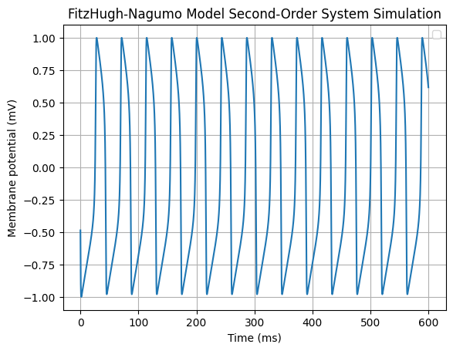

1. **Parameter :** The parameter governs the time dependency of recovery variable and a decrease in this parameter leads to increased recovery time with lower firing rates useful in simulating neurons that exhibit slow recovery kinetics. On the other hand, a large shortens recovery time but may increasing the firing rate of neurons. The effect of adjusting ε is that more can be learned about the model and the different types of neurons that respond to it at different speeds.

1. **Parameters and :**

* **Parameter :** alters the value of that marks the recovery period in the cycle It means that changing shifts the baseline level of the recovery variable and determines the action potential. For a higher value of is associated with lowering of the threshold such that enhance the ability to activate the neuron; while a smaller value increases the threshold such that deteriorates the ability of a neuron to be activated.

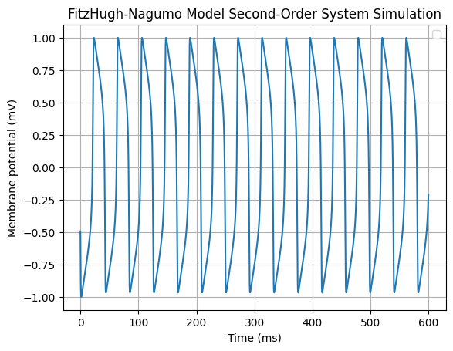

* **Parameter :** Affects the strength of the feedback loop between and . Changing the value of shifts the nature and stability of the neuronal oscillations observed. The effect of increasing is that the feedback is reinforced so oscillatory behavior is more pronounced whilst, if is decreased the feedback is dampened leading to stable but less dynamic behavior.

 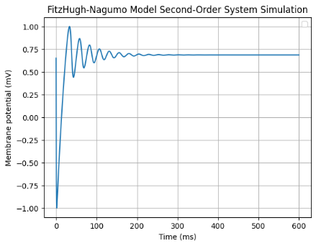

By systematically varying these parameters, researchers can manipulate these cells to exhibit a large range of neuronal activities and obtain useful information regarding the keywords of neuronal excitability and action potential generation. The possibility to come up with various conditions for analysis and simulation makes the FitzHugh-Nagumo model one of the effective computational models in neuroscience which help in educational processes and research.

***Use empirical data to tune the parameters of a simulation model:***

It can be found in the “Marwan AlFarah MS part 1 notebook Spring 23-24.ipynb” file attached.

***Apply different optimization techniques to tune simulation parameters:***

It can be found in the “Marwan AlFarah MS part 1 notebook Spring 23-24.ipynb” file attached.

# ***Task II***

***Design a detailed workflow for solving a specific problem using modeling and simulation:***

To solve the single-neuron modeling problem using modeling and simulation, we have a detailed plan which starts with defining the problem and ends with analyzing the results. This plan makes sure that every part of the simulation is handled in order, from the start to the end.

**Step 1: Define the Problem:** Our main goal is to model and simulate how a single neuron works using the FitzHugh-Nagumo model. Some of the fundamental questions we need to examine are: How does the neuron create and propagate action potentials? What are the implications of different parameters on neuron behavior? What are the implications of different parameters on neuron behavior?

**Step 2: Literature Review and Model Selection:** It involves analyzing past work on single-neuron models, with an emphasis on the FitzHugh-Nagumo model, which was chosen for its mix of simplicity and capacity to capture fundamental neural dynamics.

**Step 3: Mathematical Formulation (Differential Equations)**:

* **Membrane Potential Equation:**
* **Recovery Variable Equation:**

**Step 4: Parameter Initialization**

* **Parameters**:
* External Current
* **Initial Conditions**:
* Membrane potential
* Recovery variable
* **Simulation Settings**:
* Time step
* Total time

**Step 5: Simulation of First-Order System:** It comprises constructing two Python classes to simulate each equation of the FitzHugh-Nagumo model in its own class, and then perform the simulation for the first-order system, and provide charts for membrane potential, recovery variable, and input current over time.

**Step 6: Simulation of Second-Order System:** It comprises updating the Python class to simulate the second-order system using input current as a function of time, performing the simulation for the second-order system, and then creating charts for membrane potential and input current over time.

**Step 7: Incorporate Empirical Data:** It comprises obtaining actual data from the Allen Brain Atlas, normalizing and downsampling the data, and lastly comparing simulated findings with real data.

**Step 8: Optimization of Parameters:** Applying numerous optimization approaches such as: Simulated Annealing, Gradient Descent, and Genetic Algorithm to fine tune model parameters. The objective is to reduce the mean squared error (MSE) between simulated and empirical data. Finally, we create charts illustrating the optimal simulation results and cost history.

**Step 9: Analysis and Interpretation:** It comprises analyzing the performance of the model and the consequences of parameter adjustments, and draw conclusions about neuronal activity and the usefulness of different optimization strategies.

**Step 10: Report Preparation and Submission**: It comprises recording the entire process, including theoretical background, techniques, findings, and conclusions, and generating the final report and submit all needed files.

**Flowchart**

Here’s a diagram depicting the detailed workflow:

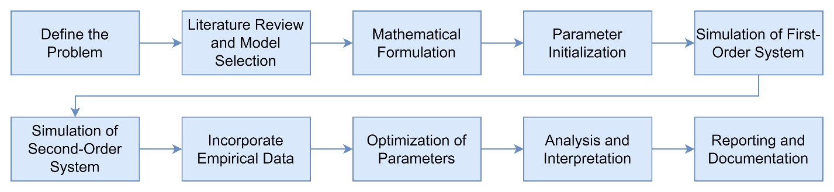

***Evaluate the performance of the second-order system in achieving desired behavior:***

In an attempt aimed at determining how effective the second order FitzHugh Nagumo system is, different variables of the system were modeled for a period of time and from the model the membrane potential and input current were analyzed. These results were compared with experimental data from neuronal recordings of subjects.

**Second-Order System Simulation:**

1. **Membrane Potential**:

* Figure 1 captured below depicts the fluctuations of membrane potential plot which is oscillating in a regular fashion with periodicity in the time span of the simulation, and the potential fluctuates between -1 to 1 indicating the presence of stable and repetitive cycles. This kind of behavior in the membrane potential is typical for the FitzHugh-Nagumo model under the specified parameters and reflects the model capacity to deliver self-sustained oscillatory activity.

**Figure 1 – Membrane potential of the second-order system simulation over time**

1. **Input Current**:

* The input current plot illustrated in Figure 2 shows that the cell maintained a steady current of 110 pA during the simulation time. This sounds like a constant input is necessary for sustaining the oscillatory nature of the membrane potential shown on the graph.

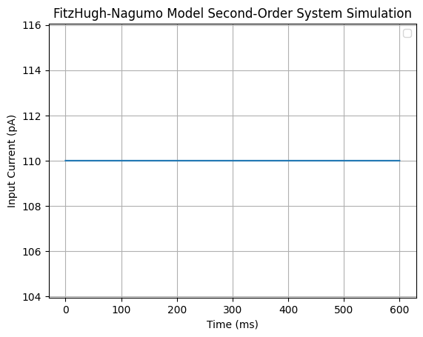  
**Figure 2 – Input current of the second-order system simulation over time**

**Empirical Data:**

1. **Membrane Potential**:

* Comparing the results of the empirical data of the membrane potential in Figure 3 with that of the simulation results, the oscillations are not as quite regular though they more or less follow those of the simulation. The potential changes within the similar range, however, the shape and the timing of oscillations can be different even if the changes are induced by the same signal, which is an actual peculiarity of biological data.

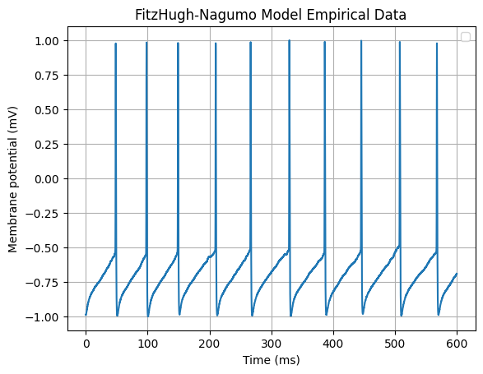  
**Figure 3 – Membrane potential of the empirical data over time**

1. **Input Current**:

* As in the case with the simulation results, the input current plot of Figure 4 for the empirical data remains almost constant at a value of approximately 110pA through out the recording time. This way, it conforms to the input conditions for the simulation applied in the study.

**Figure 4 – Input current of the empirical data over time**

**Comparison and Performance Evaluation**

The steady state behavior of this system is the FitzHugh-Nagumo second-order system that exhibits the capability of generating rhythmic, and periodic variations ine membrane potential which is a desirable feature for neuronal activity. The empirical data is more noisy and jittery because of biological noise and factors that are not captured by the model hence exhibiting random fluctuations at different time scales.

**Evaluation Metrics**

The performance of the second-order system was assessed using the following metrics:

* **Pattern Matching:** There is a good correlation between the simulated data and the empirical results presented thereby establishing that the models used are a good representation of the real-life conditions with regards to the oscillation of the membrane potential. The quantity in which the membrane potential rises is very close to the empirical data in the context that it initially curved upwards, and then sharply rose as the next phase. However, in terms of depolarization and repolarization and hence the overall loss of membrane potential, the successful patterns are not depicted well in the simulation because in the simulation it takes a lot of time for the membrane potential to get back to -1 after having reached the peak, whereas in the empirical data it is observed to almost get to -1 as soon as the peak is reached. Apart from that we can argue that in the simulation the number of peaks is 14, while the empirical data has only ten of them.
* **Mean Squared Error (MSE):** The mean of squared differences between the sampled and simulated membrane potential, measured as the measure of discrepancy. The obtained values of the second-order system and the empirical data had an MSE of 0.8841727848606492.

The constant input current in both the simulation and empirical data provides a controlled environment to compare the model’s performance. The key observations are:

* The second-order system reproduces the dominating oscillatory dynamics of the neuronal membrane potential.
* The amplitudes and frequencies of the oscillations obtained in the simulation correspond closely with the predictions from the simple model of the FitzHugh-Nagumo neuron.
* Another argument that can be made based on the empirical data’s characteristics is that biological systems’ real-world behavior includes noise, so models should cover it.

In conclusion, the second-order system without parameter optimization indicated relatively good performance in terms of experimental oscillatory patterns, suggesting it could be a useful tool for investigating neuronal dynamics and modelling neuronal responses. Some upgrades which can be made in the future could be to also include noise and other biologic matters into the model so that it is improved in accuracy.

***Analyze the effectiveness of each optimization technique for tuning the parameters of the simulation using empirical data:***

1. **Simulated Annealing:**

* **Membrane Potential over Time:** The simulated membrane potential (blue) using the simulated annealing approach shows relatively stable and low amplitude oscillations. Relative to the predicted values (blue), the observed data (red) show higher amplitude and higher frequency of fluctuations, or stronger, more frequent cycles. This suggests that whilst simulated annealing achieved stability in the model, it failed to capture the dynamic range and frequency of the empirical data accurately.

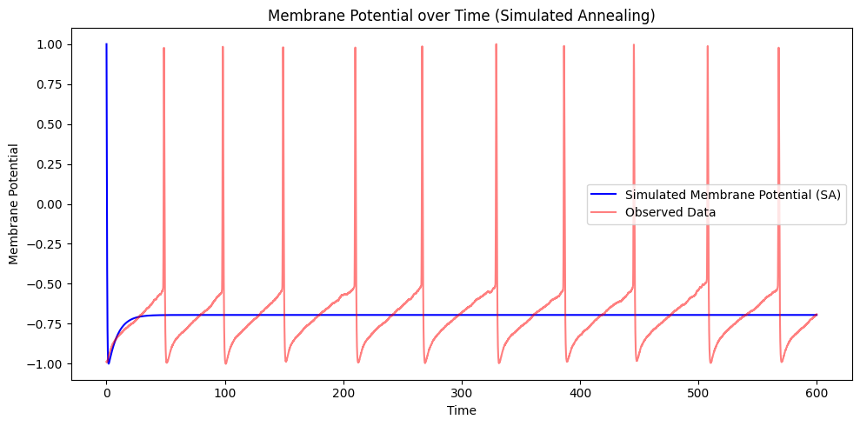

* **Cost History:** In cost history chart we observe that within the initial iterations there is reduction in the cost and then the cost remains almost stable which indicates the convergence as shown below. Despite the high initial cost, the rapid decline proves that the algorithm learns how to decrease the cost function. However, the membrane potential that was found does not accurately match the data that was collected, suggesting that the method needs to be tweaked or a new approach should be used.

1. **Gradient Descent:**

* **Membrane Potential over Time:** The membrane potential generated by using the gradient descent method (blue) also depicts stable low-amplitude oscillations. Similar to the simulated annealing results, the observed data (red) has higher amplitude and more fluctuating pattern in comparison with the simulated annealing results. This indicates that while using the gradient descent to reduce the cost as shown below is commendable, it failed to mimic the behavior that can be observed from empirical studies.

* **Cost History:** The value of the cost function reduced dramatically with the first 200 iterations and afterwards, decreases continuously slightly, which shows the convergence. Such behavior demonstrates that the algorithm for gradient descent was effective in reducing the cost function. However, the low amplitude of the membrane potential and the infrequent oscillations make it clear that this optimization method does not reflect the full nature of the empirical data.

1. **Genetic Algorithm:**

* **Membrane Potential over Time:** The results of the genetic algorithm applied to the simulated membrane potential (blue) compared to the original data (red) indicate higher amplitude and increased frequency of oscillations. This pattern is closer to observed data (in red) than patterns produced with the simulated annealing and the gradient descent techniques. The genetic algorithm’s ability to produce higher amplitude oscillations suggests a better fit to the empirical data, capturing the observed dynamics more accurately.

* **Fitness History:** Looking at the fitness history chart, it is also observable that after few generations the fitness level rises up and that after few more generations the level of fitness is relatively constant allowing us to conjecture that an algorithm has converged. The algorithm effectively maximized fitness, demonstrating its success in optimizing the model parameters. The obtained membrane potential is quite close to the empirical data, and therefore the reliability of the genetic algorithm can be considered as a more effective method for this problem in comparison with the methods used herein.

* **Simulated Annealing and Gradient Descent:** Both techniques demonstrated stable but low amplitude oscillations in the simulated membrane potential, failing to capture the observed data’s full dynamics accurately. While both methods effectively minimized the cost function, their resulting membrane potentials did not reflect the empirical data’s amplitude and frequency.
* **Genetic Algorithm:** Both techniques presented small-amplitude, and steady oscillations, failing to approximate the simulated membrane potential, and in the process, not very accurate to the observed data. While both methods effectively minimized the cost function, their resulting membrane potentials did not reflect the empirical data’s amplitude and frequency.

The analysis similarly reveals that genetic algorithm produced the best results compared to simulated annealing and gradient descent in providing better results of the oscillations of the observed data; hence, the genetic algorithm is the best optimization technique to use in this application.

# ***Task III***

***Investigate Previous Methods and Work done in the field of Neuronal Modeling***

Neuronal modeling is a fundamental component of computational neuroscience, focusing on the complex dynamics of neural systems demonstrated through mathematical and computational techniques. There are many approaches and concepts that were formulated in an attempt of describing the behavior of neurons over the years, which offers important perspectives into the works of the brain. This section gives a brief account of the research done so far and the methodologies employed in neuronal modeling focusing on single neuron models, network simulations, optimizations, and newcomers to data-driven methods.

**Single-Neuron Models**

The Hodgkin Huxley model put forward by Hodgkin and Huxley in 1952 is among the first models proposed to describe the neuronal modelling process This focuses on the ionic mechanisims of the generation and propagation of action potentials in the squid giant axon. This model involved some nonlinear differential equations to describe electrical properties of excitable cells: this has influenced the studies following this one (Hodgkin & Huxley, 1952).

On the basis of the established Hodgkin-Huxley’s equations, the FitzHugh-Nagumo model was developed to simplify the complex dynamics into a more manageable form preserving excitability and oscillation (FitzHugh, 1961; Nagumo et al. , 1962). The FitzHugh-Nagumo model is used to provide a mathematical framework to facilitate analytical and numerical studies of the nerve impulse generating mechanism to serve as a cornerstone for understanding action potentials (FitzHugh, 1961; Nagumo et al., 1962).

In the 1960’s, the integrate-and-fire model emerged as another choice of representing the neuron’s activity. This model proposes the membrane potential voltage of the neuron as a linear integration of incoming synaptic inputs until reaching a threshold. Variants of this model, including the leaky integrate-and-fire model, incorporated mechanisms intended to explain the decay of the membrane potential over time. These models are low on computational complexity and have been used in large scale simulations of neural networks (Burkitt, 2006).

Another example of single-neuron models is the Morris-Lecar model which considers the dynamics of the membrane potential dynamics of barnacle muscle fibers. Simpler calcium dynamics and Hodgkin-Huxley-type kinetics are incorporated in this model, making it suitable for analyzing bifurcation and neuronal excitability (Morris and Lecar, 1981). The model’s ability to capture a range of neuronal behaviors has made it a valuable tool in neuroscience research.

**Comparative Analysis of Neuronal Models**

It has been only through the comparative analysis of different neuronal models that it has been possible to get a feel of how effective or ineffective they could be. For example, although employing the Hodgkin-Huxley model provides detailed biological insights, it is computational expensive to implement due to its complexity. There are also less detailed models, such as, FitzHugh–Nagumo and integrate-and-fire that are less complex and computationally less demanding compared to the former ones, but may lack detailed biophysical accuracy.

Recent development in this area has involved the development of the so-called hybrid models that effectively build on the best of both biophysical and phenomenological approaches. They tend to be relatively fast while retaining the favor of biologists, making these models general and powerful enough to encode the dynamics of neurons across all scales and conditions.

**Network Simulations**

As mentioned earlier neuronal networks, that include neurons interlinked with one another, exhibit a higher level of complexity. The most significant example of a network model is the integrate-and-fire model that roughly imitates the neuron firing and synaptic processes based on the threshold dynamics (Abbott, 1999). This model has been widely applied because of its computational efficiency as well as the ability to capture some crucial behaviors of the network.

Large-scale spiking neuron networks, exemplified by the Blue Brain Project, aim to reconstruct and simulate the mammalian brain at the cellular level. This has been made with the use of high-performance computing to produce accurate simulations of neural circuits and offer understanding of the structural and organizational patterns in the brain (Markram, 2006).

Subsequently, Izhikevich (2004) presented a model that incorporated the biophysical realism of the HH model with the computational simplicity of the I&F model. This particular model is thus described by many as a versatile hybrid model adopted for large-scale simulations of the cortical networks, given its flexibility and the capacity for computational intricacy (Izhikevich, 2004).

**Optimization Techniques**

In neuronal techniques, model parameters optimization is an important stage since they affect the reproduction of biological phenomena. Genetic Algorithms, Annealing techniques and many others have been used to determine model parameters by fitting the simulated output with the experimental data. For example, Vanier and Bower (1999) have used GA in optimizing a multicompartmental neuron model and thereby illustrating itself as a potent tool in computational neuroscience (Vanier & Bower, 1999).

Bayesian optimization is also used in turn as a strong tool for parameter tuning in the models that were implemented with high-dimensional parameter space. This approach uses probabilistic models to help search for the best parameters eliminating the need for more complicated computations than the ones being required by traditional methods (Snoek et al., 2012). Moreover, neural networks and support vector machines have been applied in the optimization framework, to ensure and enhance the accuracy and efficiency of the parameter estimations (Goodfellow, Bengio, & Courville, 2016).

**Advances in Data-Driven Techniques**

Recently, with the advance of large-size neural recording technologies, data-driven modeling has come to the front. The electrophysiological data has been offered by Allen Institute for Brain Science, which has offered enormous amount of datasets that have been vital in designing and testing neuronal models (Allen Institute for Brain Science, 2024). It is always vital to develop a model that reflects the real world and such datasets would help the researchers do just that.

To accommodate large datasets and extract features that may be hidden from the data that traditional methods might miss, techniques such as machine learning and deep learning are increasingly being integrated into neuronal modeling. In LSTM networks, dependence on the temporal sequence in neural data is modeled effectively, and overall prediction accuracy enhanced thus mitigating the effects of vanishing gradients and capturing long-range dependencies (Hochreiter & Schmidhuber, 1997).

In addition, the advancement of reinforcement learning in connection with neuronal modeling has opened new avenues for understanding synaptic plasticity and learning mechanisms in the brain. Some types of reinforcement learning algorithms have been used to simulate the adaptive behavior of neural circuits thus undertanding how learning happens on the synaptic level (Sutton and Barto, 2018).

**Conclusion**

The field of neuronal modeling has evolved significantly, from the detailed Hodgkin-Huxley model up to large scale neuronal network simulations and advanced optimization methods. Each of these models has been of great use for the understanding of the properties of the neural systems, which served as a theoretical framework for farther research regarding neuroscience as well as applications in neural systems. As computational resources and data accessibility are expanding, one can expect further progress in the neuronal modeling based on data-driven approaches and employing machine learning techniques.

***Critically analyze and compare the performance of different models used for neuronal modeling and simulation***

Two widely used models are the FitzHugh-Nagumo (FHN) model and the Leaky Integrate-and-Fire (LIF) model. This section provides a critical analysis of these models and their performance in replicating neuronal activity and their implementations as well as the results that were achieved from optimization techniques.

**FitzHugh-Nagumo Model**

The FitzHugh-Nagumo model is derived from the Hodgkin-Huxley model designed to capture the qualitative behavior of neuronal excitability and oscillations. This model is made of a system of differential equations in which the membrane potential and a recovery variable are the main components.

* **Parameters:** , , , or
* **Initial conditions:** ,
* **Simulation time:**  though the elapsed time step dt has been taken to be equal to

**Model Performance:**

* **First-Order System Simulation:** The membrane potential exhibits a starting value at 1.0 mV which immediately drops to -1.0 mV which stays constant throughout the simulation. As for the simulation for the recovery variable, it starts at 1.0, then slowly converges to -1.0 after 100 ms and it stays at -1.0 for the rest of the simulation. The input current remains constant at 110 pA throughout the simulation.
* **Second-Order System Simulation:** The membrane potential fluctuates with regular, periodic oscillations with the peaks at about 1.0 mV and troughs around -1.0 mV. It is also apparent that the input current stays constant at 110 pA during the simulation does not alter by time.
* **Empirical Data Comparison:** The experimental evidence shows a more complex structure where occasional high-frequency, high-amplitude spikes are seen, suggesting that any complexity of the FHN model which exhibits simple periodic oscillations is insufficient to model neuronal activity.

**Leaky Integrate-and-Fire Model**

Leaky Integrate-and-Fire is a simplified model of neuronal spiking activity characterized by a linear integration of the input current and resets when the voltage crosses a certain threshold.

* **Parameters:** , , , ,
* **Initial condition:**
* **Simulation time:**  with a time step

**Model Performance:**

* **Simulated Membrane Potential:** The LIF model produces regular, periodic firing with linear increases in membrane potential until the threshold is reached, followed by a reset. This behavior corresponds to the firing pattern of neurons but it does not incorporate complex details observed in live neurons.
* **Empirical Data Comparison:** The observed data shows sharp, high-amplitude spikes followed by rapid resets, which are more intricate than the simple periodic firing captured by the LIF model.

**Optimization Techniques and Performance**

Different techniques of model optimization were used for both models to adjust certain parameter’s coefficients and improve the fit to empirical data. These include the methods of Simulated Annealing, Gradient Descent, and Genetic Algorithm.

**Simulated Annealing:**

* **FitzHugh-Nagumo:** It obtained its best cost at 0.0444, with parameters , , . The simulated membrane potential remained largely constant, failing to replicate the high amplitude oscillations.
* **Leaky Integrate-and-Fire:** Achieved a best cost of 0.9957, with parameters , . The simulated potential exhibited periodic firing but with exaggerated amplitudes compared to empirical data.

**Gradient Descent:**

* **FitzHugh-Nagumo:** Achieved a best cost of 0.0447, with parameters , , . The result was similar to simulated annealing, showing periodic oscillations.
* **Leaky Integrate-and-Fire:** Achieved a best cost of 1.0219, with parameters , . The periodic firing behavior was similar to the result from simulated annealing.

**Genetic Algorithm:**

* **FitzHugh-Nagumo:** Achieved a best fitness of -0.5485, with parameters a=0.4504, b=0.9358, ϵ= 0.0833. This method produced high amplitude oscillations but tended to overshoot the target behavior, however, in terms of pattern matching, it was the closest to the empirical data.
* **Leaky Integrate-and-Fire:** Achieved a best fitness of -0.0635, with parameters , . The periodic firing behavior was similar to the result from simulated annealing and gradient decent.

**Comparative Analysis**

* **Model Complexity and Dynamics:**
* In fact, the FitzHugh-Nagumo model has a considerably less computational complexity than the Hodgkin-Huxley model and still captures many of the essential qualitative behaviors of neuronal excitability and oscillations. But the oscillations of the model are periodic and do not accurately mimic high-frequency spiking activity present in real-world conditions.
* Leaky Integrate-and-Fire is perhaps as good as it gets for the basic firing mechanism of neurons, which is to spike and then reset itself. However, it lacks the ability to capture the rapid spike and complex post-spike behavior seen in actual neuronal activity.
* **Optimization Effectiveness:**
* **Simulated Annealing and Gradient Descent:** The two approaches offered decent parameter sets to both models. However, they did not capture all the details of the empirical findings in the sample. The cost values therefore suggest that although these methods yields better fit for the model, they actually result in convergence to a suboptimal solution.
* **Genetic Algorithm:** In this method, it was also possible to find high fitness values giving information about the parameter space. Nonetheless, the values of parameters for the LIF model which were obtained appeared quite unreasonable thus there is the necessity of further definition of the bounds of parameters and the concepts of fitness functions.
* **Empirical Data Fit:**
* Basically, neither model could reproduce the neuronal dynamics to the extent as were observed. Unlike the empirical data, the FHN model oscillates, and the LIF model has a periodic firing mechanism that is not capable of generating the high-amplitude high-frequency spiking regarded.
* Higher accuracy could be achieved if the further refinement, or the models containing some elements of both FHN and LIF models or purely more complex models such as Hodgkin-Huxley are used in modeling observed neuronal behavior.

**Conclusion**

The FitzHugh-Nagumo and Leaky Integrate-and-Fire models are essential models as they give an insight of the neuronal activity considered from two distinctive angles. The optimizations methods used brought better fit on the data while at the same time revealing weaknesses in both models. Thus, the FitzHugh-Nagumo model is more justified in terms of neuronal excitability, and the Leaky Integrate-and-Fire model adequately describes primary firing processes. Future work should continue the development of these models and look into hybrid approaches or even more complex models and should make sure that the parameters that go with optimization techniques range realistically so that the neuronal activity can be simulated as closely as possible as they are in the actual world.

# ***References***

Abbott, L. F. (1999). Lapicque’s introduction of the integrate-and-fire model neuron (1907). Brain Research Bulletin, 50(5-6), 303-304.

Allen Institute for Brain Science. (2024). Allen Cell Types Database. Available at: https://celltypes.brain-map.org/experiment/electrophysiology/474626527

Awile, O. et al. (2022) ‘Modernizing the NEURON Simulator for Sustainability, Portability, and Performance’, Frontiers in Neuroinformatics, 16, p. 884046.

Brunel, N., Hakim, V. and Richardson, M.J.E. (2014) ‘Single neuron dynamics and computation’, Current Opinion in Neurobiology, 25, pp. 149–155.

Burkitt, A.N. (2006) ‘A review of the integrate-and-fire neuron model: I. Homogeneous synaptic input’, Biological Cybernetics, 95(1), pp. 1–19.

Carnevale, T. (2007) ‘Neuron simulation environment’, Scholarpedia, 2(6), p. 1378.

D’Angelo, E. et al. (2013) ‘Realistic modeling of neurons and networks: towards brain simulation’, Functional Neurology, 28(3), p. 153.

Einevoll, G.T. et al. (2019) ‘The Scientific Case for Brain Simulations’, Neuron, 102(4), pp. 735–744.

FitzHugh, R. (1961). Impulses and physiological states in theoretical models of nerve membrane. Biophysical Journal, 1(6), 445-466.

Goodfellow, I., Bengio, Y., & Courville, A. (2016). Deep Learning. MIT Press.

Herz, A.V.M. et al. (2006) ‘Modeling single-neuron dynamics and computations: A balance of detail and abstraction’, Science, 314(5796), pp. 80–85.

Hines, M.L. and Carnevale, N.T. (1997) ‘The NEURON Simulation Environment’, Neural Computation, 9(6), pp. 1179–1209.

Hochreiter, S., & Schmidhuber, J. (1997). Long short-term memory. Neural Computation, 9(8), 1735-1780.

Hodgkin, A. L., & Huxley, A. F. (1952). A quantitative description of membrane current and its application to conduction and excitation in nerve. The Journal of Physiology, 117(4), 500-544.

Izhikevich, E. M. (2004). Which model to use for cortical spiking neurons? IEEE Transactions on Neural Networks, 15(5), 1063-1070.

Lindsay, K.A. et al. (1999) ‘An Introduction to the Principles of Neuronal Modelling’, Modern Techniques in Neuroscience Research, pp. 213–306.

Markram, H. (2006). The Blue Brain Project. Nature Reviews Neuroscience, 7(2), 153-160.

Markram, H. et al. (2015) ‘Reconstruction and Simulation of Neocortical Microcircuitry’, Cell, 163(2), pp. 456–492.

Morris, C., & Lecar, H. (1981). Voltage oscillations in the barnacle giant muscle fiber. Biophysical Journal, 35(1), 193-213.

Nagumo, J., Arimoto, S., & Yoshizawa, S. (1962). An active pulse transmission line simulating nerve axon. Proceedings of the IRE, 50(10), 2061-2070.

Snoek, J., Larochelle, H., & Adams, R. P. (2012). Practical Bayesian optimization of machine learning algorithms. Advances in Neural Information Processing Systems, 25.

Sutton, R. S., & Barto, A. G. (2018). Reinforcement Learning: An Introduction (2nd ed.). MIT Press.

Vanier, M. C., & Bower, J. M. (1999). A comparative survey of automated parameter-search methods for compartmental neural models. Journal of Computational Neuroscience, 7(2), 149-171.